Week 2 Assignment
SQL-based data analysis using filtering, aggregation, and basic business queries

Name: Pathan Aman Firojkhan
Student ID- CT_CSI_DE_1157

Database :
Database Name : sales_db
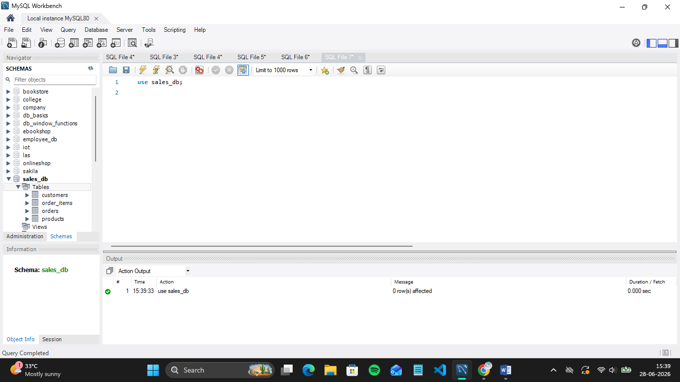

All Tables and Data of each Tables:
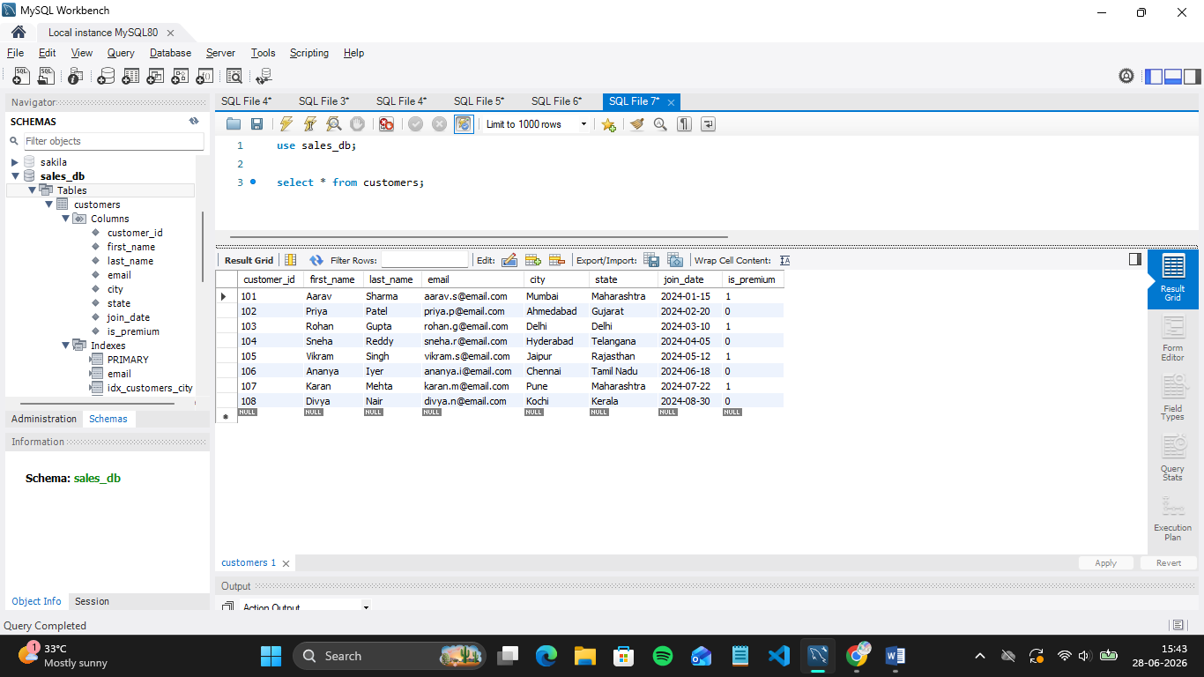
- Table Name : customers
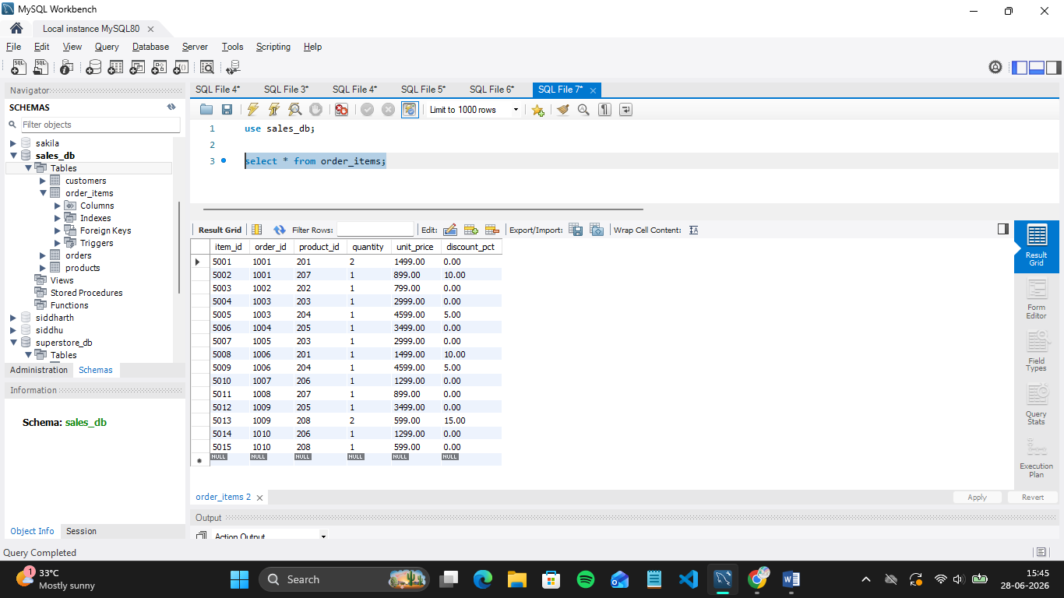
- Table Name : order_items

- Table Name : orders

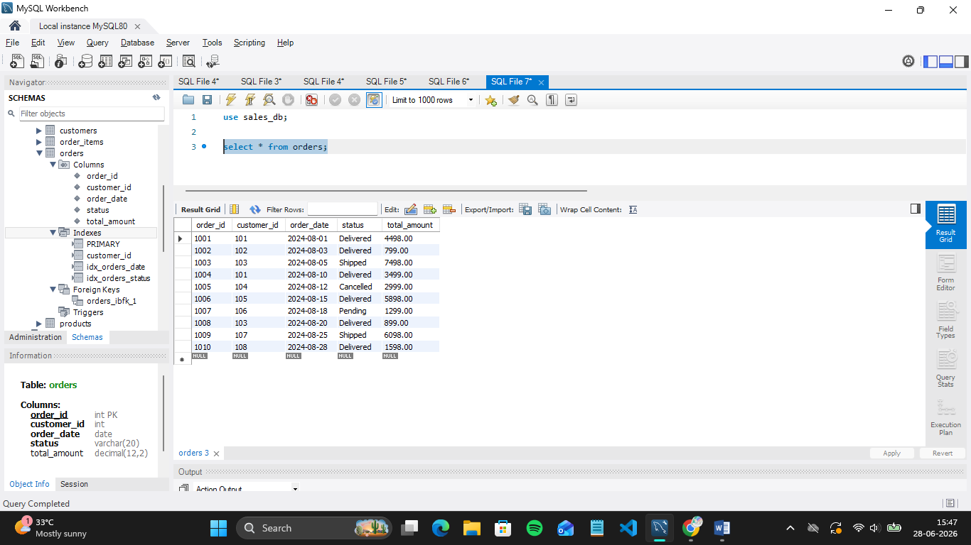

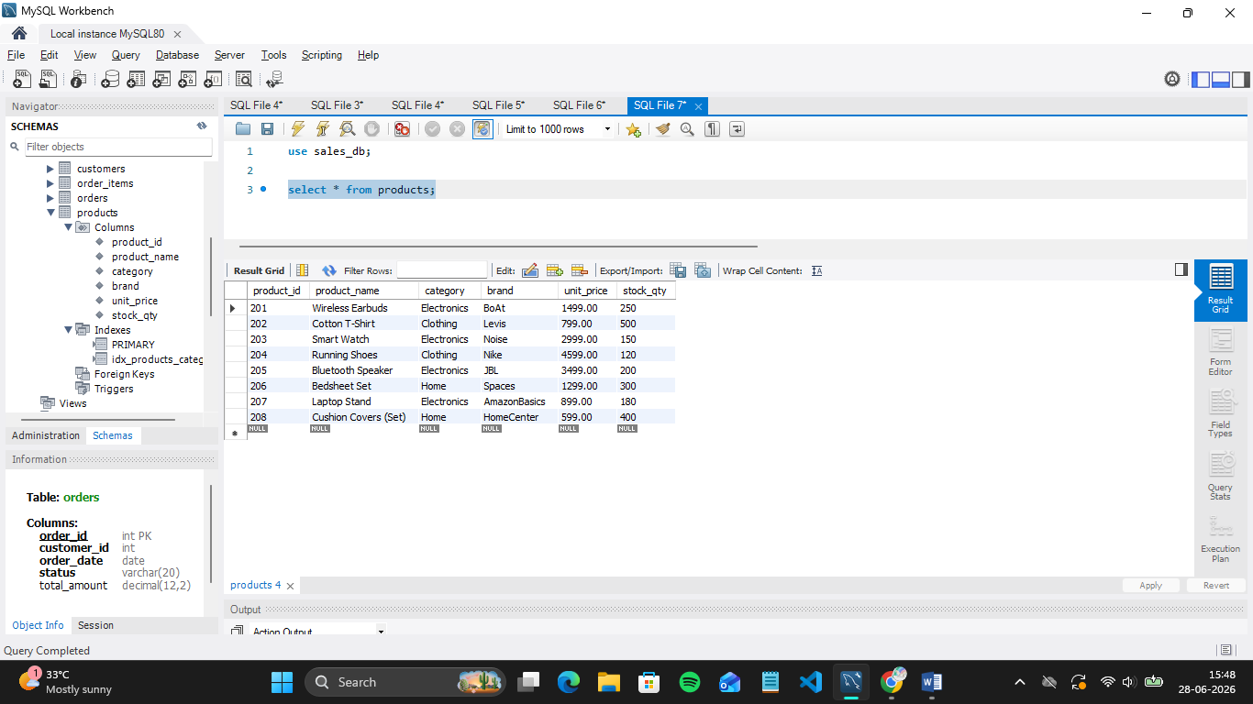
- Table Name : products

Section A — SQL Basics (SELECT, Constraints, Primary Keys)
Q1. Write a query to display all columns and rows from the customer's table.
SQL Query:
Select * from customers;

Output:


Q2. Retrieve only the first_name, last_name, and city of all customers.
SQL Query :
SELECT
first_name,
last_name,
city
FROM customers;

Output:
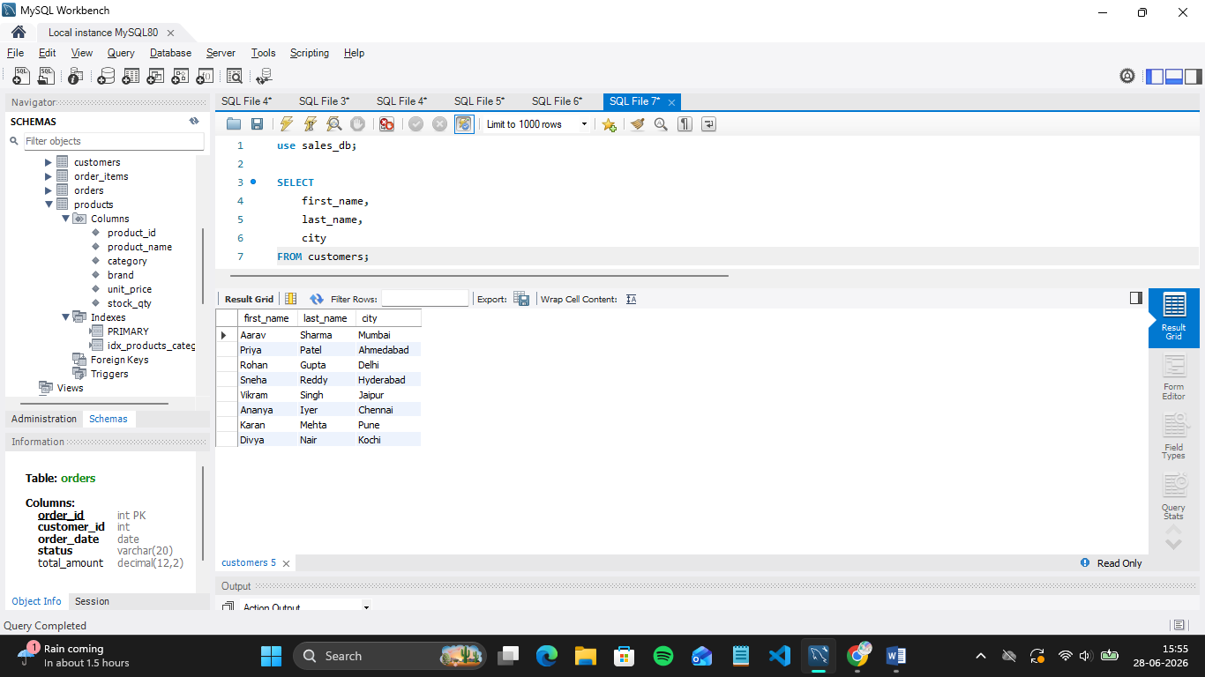

Q3. List all unique categories available in the products table.
SQL Query :
select distinct category from products;

Output :
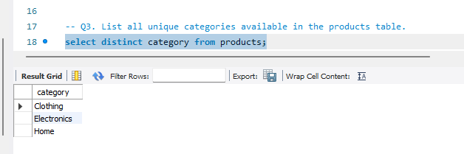

Q4. Identify the Primary Key of each table in the schema. Explain why a Primary Key must be unique and NOT NULL.

SQL Query :
desc cutomers;

Output:
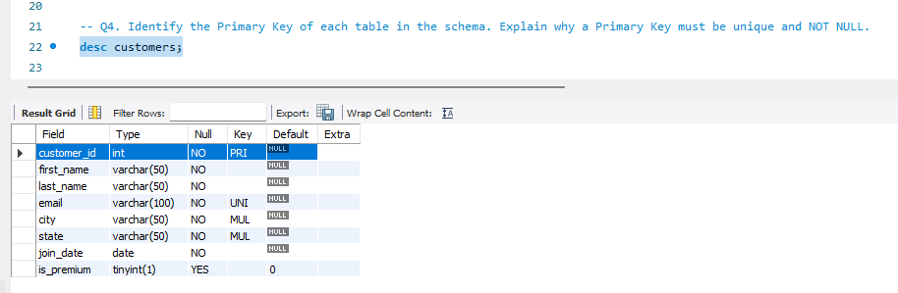

SQL Query:
desc order_items;

Output :
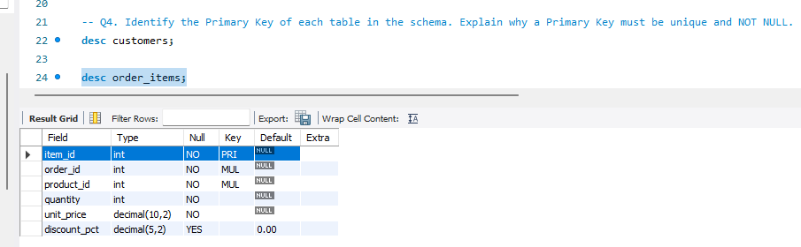

SQL Query:
desc orders;

Output:
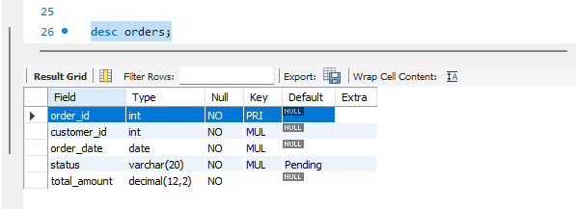

SQL Query :
desc products;

Output:
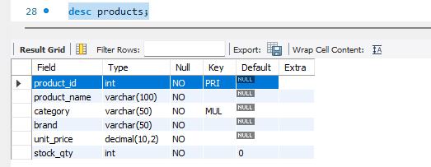

Why must a Primary Key be UNIQUE and NOT NULL?
A Primary Key uniquely identifies every row in a table.

UNIQUE:
No duplicate values are allowed.

NOT NULL:
Every row must have an identifier.

Q5. What constraints are applied to the email column in the customers table? What would happen if you tried to insert a duplicate email?

This Schema will be used :
email VARCHAR(100) UNIQUE NOT NULL

Two constraints will be applied

1. UNIQUE Constraint
Means every customer must have a different email.
Example:
Allowed:
siddharth@email.com
siddhi@email.com
Not allowed:
siddhi@email.com
siddhi@email.com

2. NOT NULL Constraint

Means email cannot be empty.
Invalid:
INSERT INTO customers(email)
VALUES(NULL);

What happens if duplicate email is inserted?
ERROR: Duplicate entry 'aarav.s@email.com'
for key 'email'

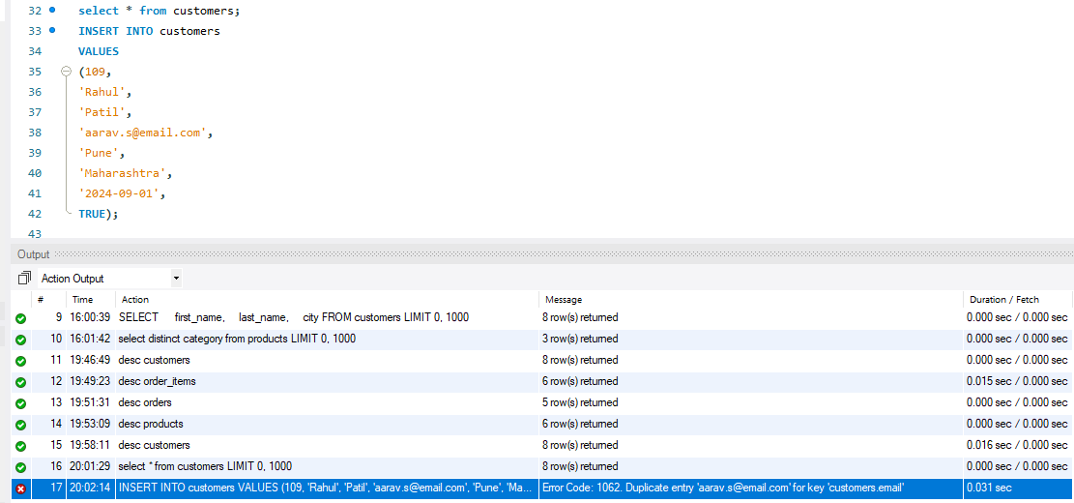

Q6. Try inserting a product with unit_price = -50. What happens and which constraint prevents it? Write both the INSERT statement and explain the error.

The product table has:
unit_price DECIMAL(10,2)
CHECK(unit_price > 0)

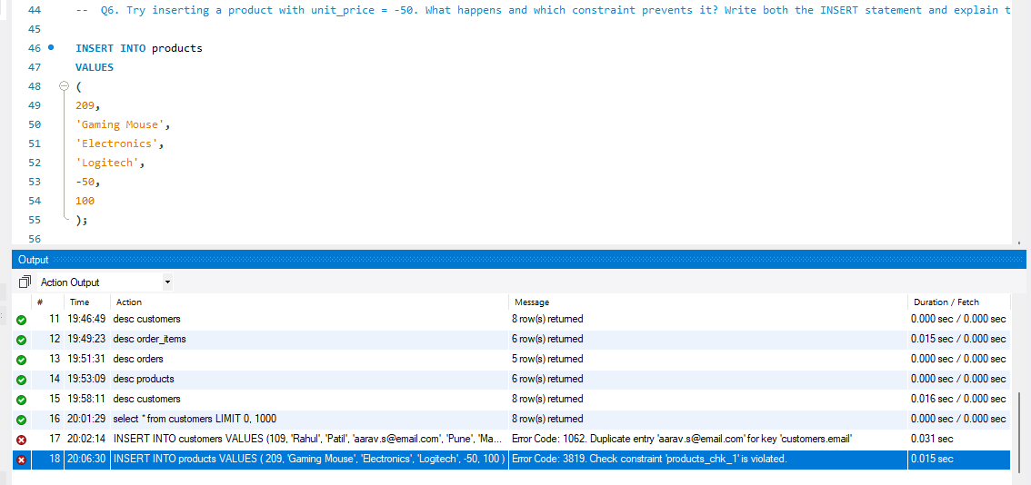

The database rejects this query.
Error example:
CHECK constraint failed:
unit_price > 0

Explanation:
The CHECK constraint validates data before inserting.
Condition:
unit_price > 0
Means:
Allowed:
499
Not allowed:
0
-50
-100
Because negative product prices are logically invalid.

Section B — Filtering & Optimization (WHERE, Indexes)

Q7. Retrieve all orders with status = 'Delivered'.

SQL Query :
SELECT *
FROM orders
WHERE status = 'Delivered';

Output:
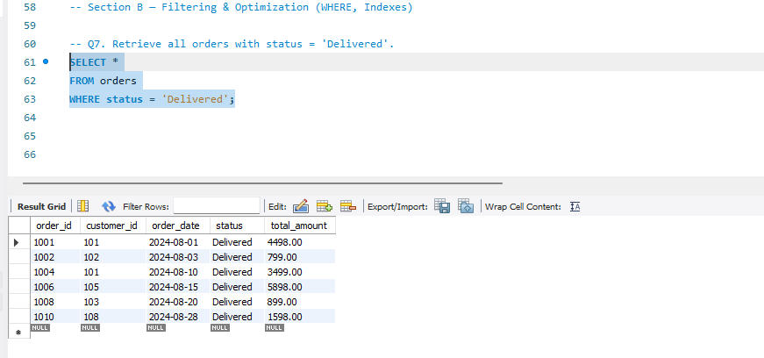

Q8. Find all products in the 'Electronics' category with a unit_price greater than ₹2000.

SQL Query :
SELECT *
FROM products
WHERE category = 'Electronics'
AND unit_price > 2000;

Output :
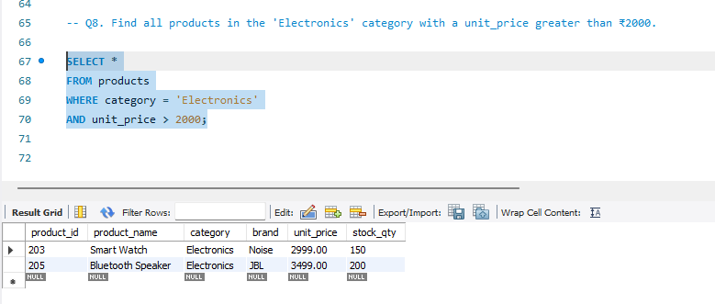

Q9. List all customers who joined in the year 2024 and belong to the state 'Maharashtra'.

SQL Query :
SELECT *
FROM customers
WHERE state = 'Maharashtra'
AND YEAR(join_date) = 2024;

Output:
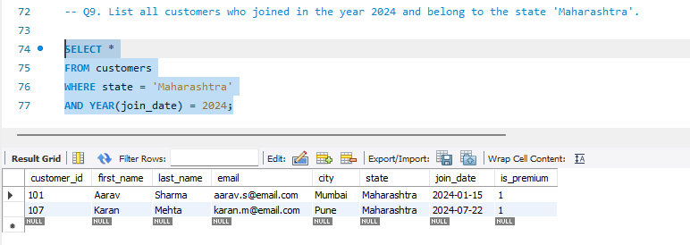

Q10. Find all orders placed between '2024-08-10' and '2024-08-25' (inclusive) that are NOT cancelled.

SQL Query:
SELECT *
FROM orders
WHERE order_date BETWEEN '2024-08-10'
AND '2024-08-25'
AND status <> 'Cancelled';

Output: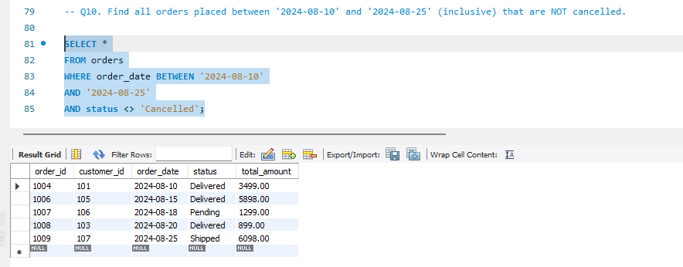

Q11. Explain what the index idx_orders_date does. How would it improve the performance of a query that filters orders by order_date? Write a sample query that would benefit from this index.

The schema contains:
CREATE INDEX idx_orders_date
ON orders(order_date);

What is an Index?
An index is a database structure that improves the speed of searching data.
It works similar to an index page in a book.

Without an index:
Database checks every row:
Order 1
Order 2
Order 3
...
Order 100000
This is called:
Full Table Scan

With an index:
Database directly finds matching dates.
Example:
2024-08-01 → Order 1001
2024-08-05 → Order 1003
2024-08-10 → Order 1004

Query benefiting from this index:

SELECT *
FROM orders
WHERE order_date = '2024-08-10';

The database can quickly locate orders on that date using:
idx_orders_date

Benefits:
- Faster filtering
- Faster sorting by date
- Better query performance for large tables

Q12. If you run: SELECT * FROM customers WHERE YEAR(join_date) = 2024; — would the index on join_date be used? Explain why or why not, and rewrite the query to be index-friendly (SARGable).

SQL Query :
SELECT *
FROM customers
WHERE YEAR(join_date) = 2024;

Output :
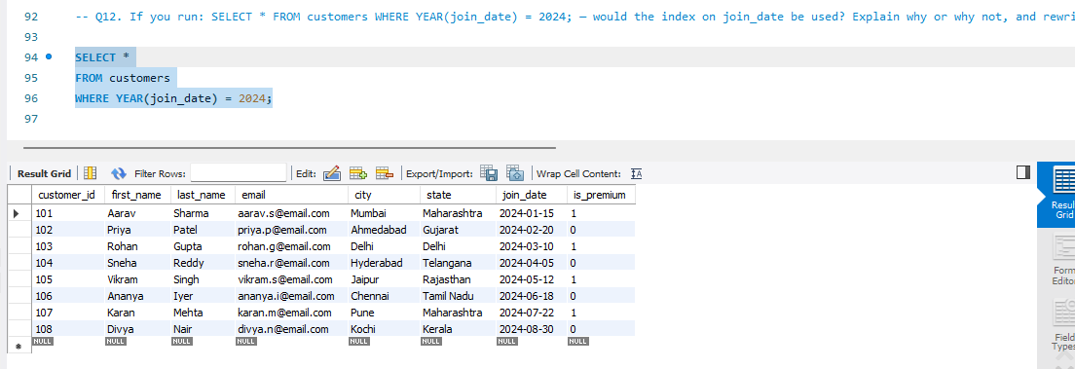

Answer:
Usually NO, the index will not be used efficiently.

Why?
Because we are applying a function:
YEAR(join_date)
The database must first calculate the year for every row.
Example:
Before searching:
2024-01-15 → YEAR() → 2024
2023-05-10 → YEAR() → 2023
2025-02-20 → YEAR() → 2025
Because the column is modified, the index cannot directly search.
This query is not SARGable.

Index-friendly (SARGable) Query:
SELECT *
FROM customers
WHERE join_date >= '2024-01-01'
AND join_date < '2025-01-01';

Why is this better?
The database can directly search the date range:
2024-01-01
|
|
2024-12-31
The index can quickly locate matching rows.

SARGable vs Non-SARGable
Type | Example | Index Usage
SARGable | join_date >= '2024-01-01' | Uses index
Non-SARGable | YEAR(join_date)=2024 | Usually avoids index

Section C — Aggregation (GROUP BY, SUM, COUNT, AVG, MIN, MAX)

Q13. Count the total number of orders in the orders table.

SQL Query:
Select count(*) as total_orders from orders;

Output:
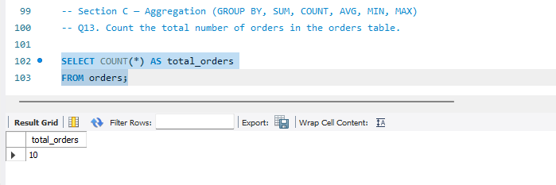

Q14. Find the total revenue (SUM of total_amount) from all 'Delivered' orders.

SQL Query :
SELECT
SUM(total_amount) AS total_revenue
FROM orders
WHERE status = 'Delivered';

Output:
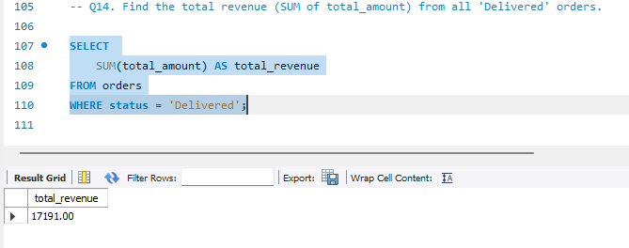

Q15. Calculate the average unit_price of products in each category.

SQL Query :
SELECT
category,
AVG(unit_price) AS average_price
FROM products
GROUP BY category;

Output:
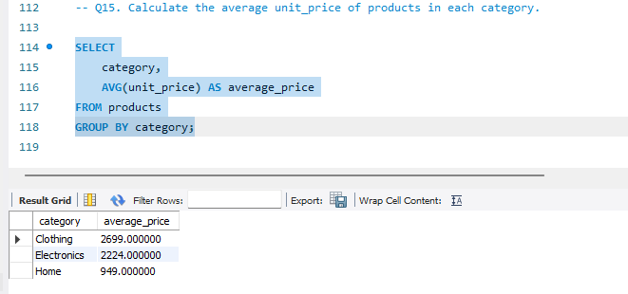

Q16. For each order status, find the count of orders and the total revenue. Sort the result by total revenue in descending order.

SQL Query:
SELECT
status,
COUNT(order_id) AS order_count,
SUM(total_amount) AS total_revenue
FROM orders
GROUP BY status
ORDER BY total_revenue DESC;

Output:
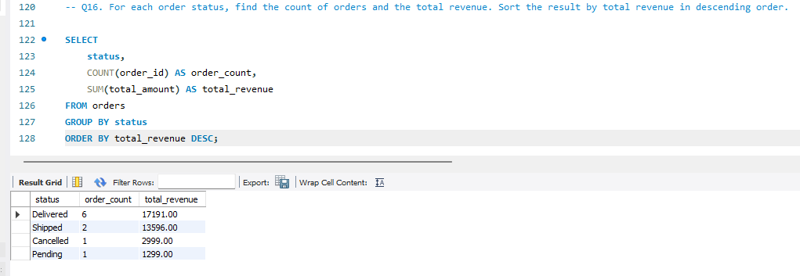

Q17. Find the most expensive (MAX) and cheapest (MIN) product in each category.
SQL Query:
SELECT
category,
MAX(unit_price) AS highest_price,
MIN(unit_price) AS lowest_price
FROM products
GROUP BY category;

Output:
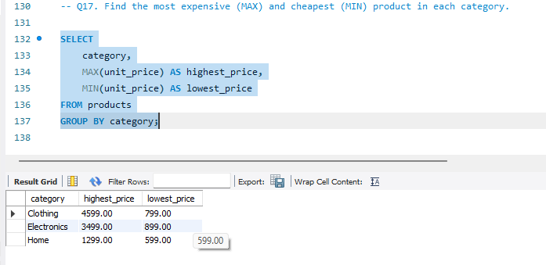

Q18. List all product categories where the average unit_price is greater than ₹2000. (Hint: Use HAVING clause)

SQL Query:
SELECT
category,
AVG(unit_price) AS average_price
FROM products
GROUP BY category
HAVING AVG(unit_price) > 2000;

Output:
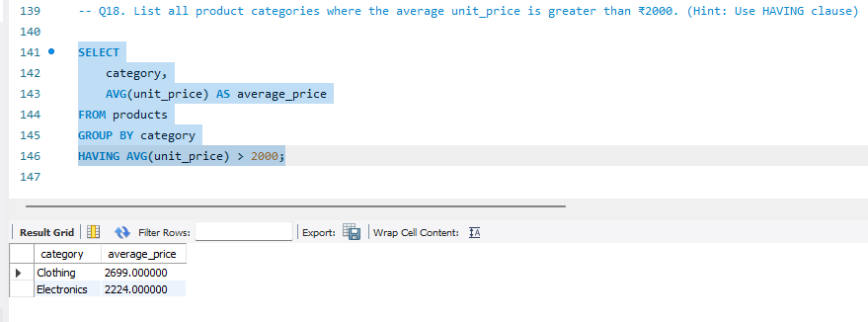
Section D — Joins & Relationships

Q19. Write an INNER JOIN query to display each order along with the customer's first_name and last_name. Show: order_id, order_date, first_name, last_name, total_amount.

SQL Query:
SELECT
orders.order_id,
orders.order_date,
customers.first_name,
customers.last_name,
orders.total_amount
FROM orders
INNER JOIN customers
ON orders.customer_id = customers.customer_id;

Output:
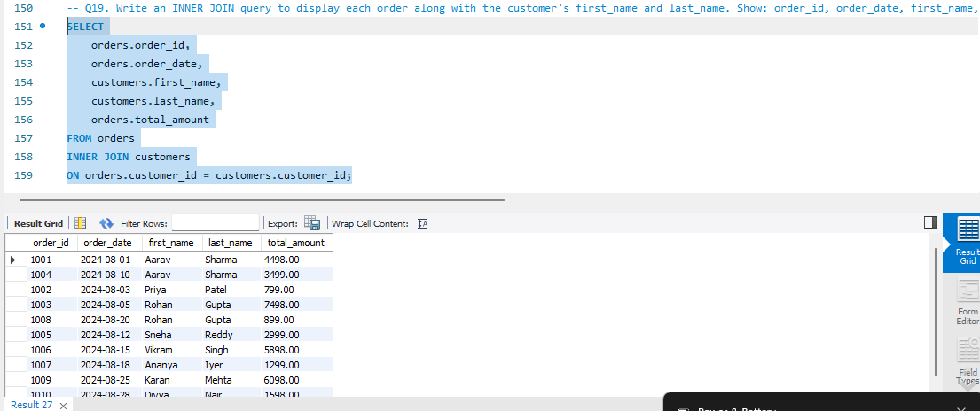

Q20. Using a LEFT JOIN, list ALL customers and their orders (if any). Customers with no orders should still appear with NULL values for order columns.

SQL Query:
SELECT
customers.customer_id,
customers.first_name,
customers.last_name,
orders.order_id,
orders.order_date,
orders.total_amount
FROM customers
LEFT JOIN orders
ON customers.customer_id = orders.customer_id;
Output:
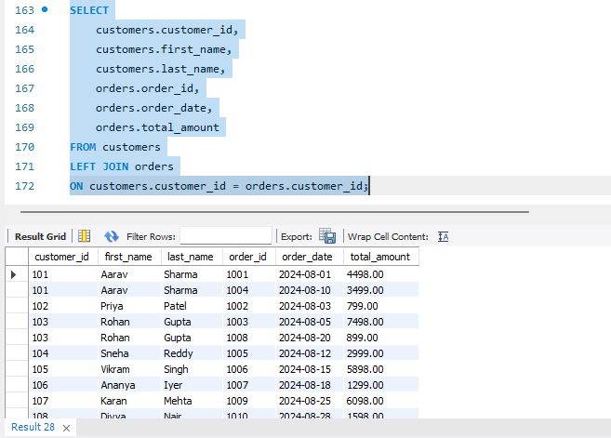

Q21. Write a query using JOINs across three tables (orders → order_items → products) to show: order_id, product_name, quantity, unit_price, and discount_pct for each order item.

SQL Query:
SELECT
orders.order_id,
products.product_name,
order_items.quantity,
order_items.unit_price,
order_items.discount_pct
FROM orders

INNER JOIN order_items
ON orders.order_id = order_items.order_id

INNER JOIN products
ON order_items.product_id = products.product_id;

Output:
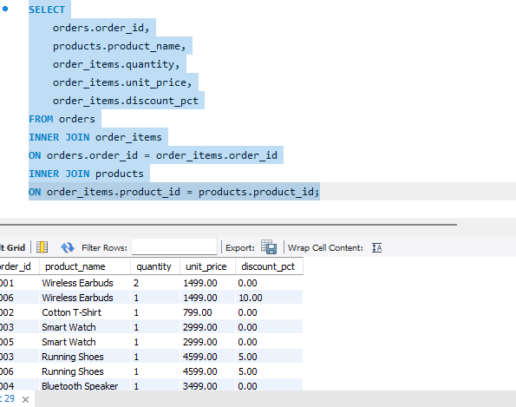

Q22. Explain the difference between LEFT JOIN and RIGHT JOIN with an example from this schema. When would you use a FULL OUTER JOIN?

SQL Query:
SELECT *
FROM customers
LEFT JOIN orders
ON customers.customer_id = orders.customer_id;

Output:
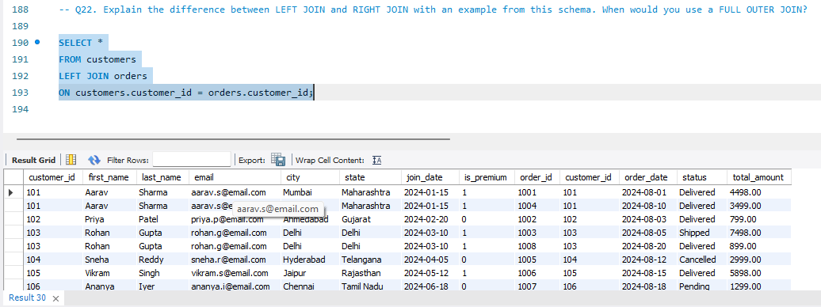
Q23. Identify all Foreign Key relationships in the schema. Explain what would happen if you tried to insert an order with customer_id = 999 (which doesn't exist in customers).

Foreign Key 1:

orders table
customer_id
References:
customers(customer_id)
Relationship:
customers
|
↓
orders

Foreign Key 2:

order_items table
order_id
References:
orders(order_id)
Relationship:
orders
|
↓
order_items

Foreign Key 3:

order_items table
product_id
References:
products(product_id)
Relationship:
products
|
↓
order_items

What happens if we insert order with customer_id = 999?
Query:
INSERT INTO orders
VALUES
(
1011,
999,
'2024-09-01',
'Pending',
1598
);

Result:
The database rejects the insertion.
Error:
Foreign Key Constraint Failed

Why?
Because:
customer_id = 999
does not exist in:
customers table
The foreign key prevents invalid references.

Why are Foreign Keys Important?
They maintain:

1. Data Integrity
Example:
Cannot create an order for a non-existing customer.

2. Relationship Accuracy
Every order must belong to a valid customer.

3. Prevent Orphan Records
Invalid data like:
Order 1011 → Customer 999
is prevented.

Output:

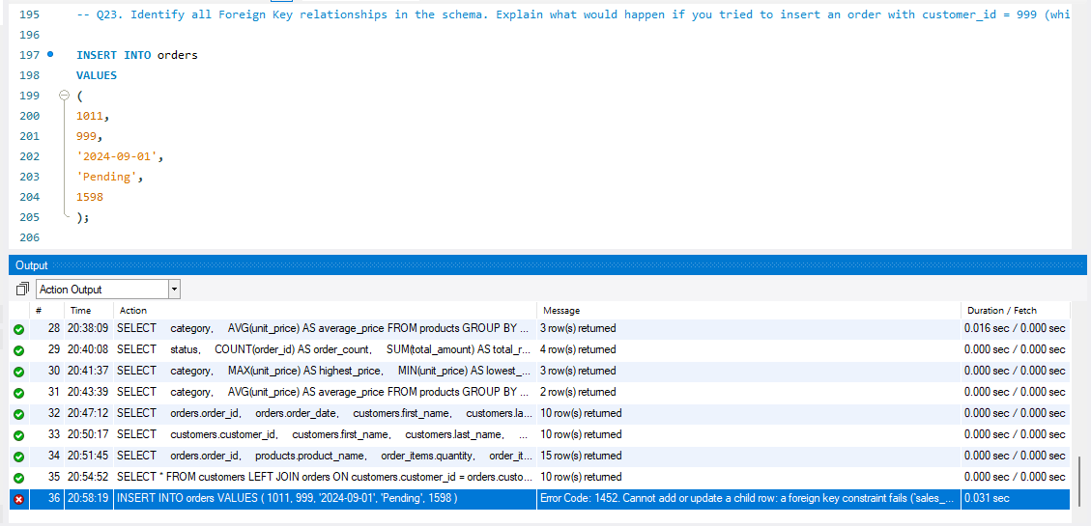

Section E — Advanced Concepts (CASE, ACID, Transactions)

Q24. Write a query using CASE to classify products into price tiers:
• 'Budget' → unit_price < 1000
• 'Mid-Range' → unit_price BETWEEN 1000 AND 3000
• 'Premium' → unit_price > 3000
Display: product_name, unit_price, price_tier.

SQL Query:
SELECT
product_name,
unit_price,
CASE
WHEN unit_price < 1000 THEN 'Budget'
WHEN unit_price BETWEEN 1000 AND 3000 THEN 'Mid-Range'
WHEN unit_price > 3000 THEN 'Premium'
END AS price_tier
FROM products;

Output:
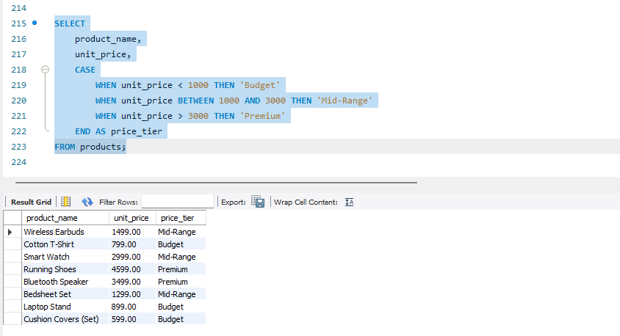

Q25. Using a CASE statement inside an aggregate function, count how many orders are 'Delivered' vs 'Not Delivered' (all other statuses). Display the result in a single row.

SQL Query:
SELECT
COUNT(
CASE
WHEN status = 'Delivered'
THEN 1
END
) AS delivered_orders,

COUNT(
CASE
WHEN status <> 'Delivered'
THEN 1
END
) AS not_delivered_orders

FROM orders;

Output:
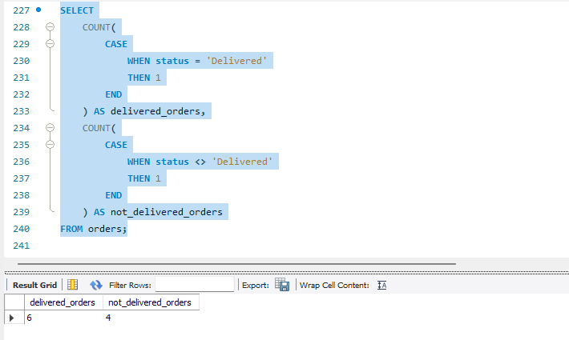

Q26. Explain each letter of ACID:
• A – Atomicity
• C – Consistency
• I – Isolation
• D – Durability
Give a real-world example (e.g., bank transfer) showing why each property is important.

ACID properties ensure database transactions are reliable and safe.
ACID stands for:
Letter | Meaning
A | Atomicity
C | Consistency
I | Isolation
D | Durability

A — Atomicity

Meaning:
A transaction is treated as a single unit.
Either: All operations succeed
OR: All operations fail

Example: Bank Transfer
Transfer ₹500 from Account A to Account B.
Steps:
- Deduct ₹500 from A
- Add ₹500 to B
If step 1 succeeds but step 2 fails:
The database cancels the entire transaction.
Money is not lost.

C — Consistency

Meaning:
Database must always remain valid before and after a transaction.
Rules and constraints must be followed.
Example:
Before transfer:
Account A = ₹5000
Account B = ₹2000
After transfer:
Account A = ₹4500
Account B = ₹2500
Total money remains:
₹7000

I — Isolation

Meaning:
Multiple transactions happening together should not affect each other incorrectly.
Example:
Two users trying to buy the last available product.
Transaction 1:
Buy product
Transaction 2:
Buy same product
Isolation ensures the database handles them correctly.

D — Durability

Meaning:
Once a transaction is committed, the changes permanently exist.
Example:
After successful payment:
Payment Successful
Even if the server crashes:
The payment record remains saved.

ACID Summary:
Property | Purpose
Atomicity | Complete or cancel transaction
Consistency | Maintain valid data
Isolation | Prevent transaction conflicts
Durability | Save committed changes permanently

Q27. Write a SQL transaction that does the following atomically:
1. Insert a new order (order_id=1011, customer_id=102, today's date, 'Pending', 1598.00)
2. Insert two order items for that order
3. Update the stock_qty of the purchased products
4. If any step fails, ROLLBACK the entire transaction. Otherwise, COMMIT.
Write the complete BEGIN...COMMIT/ROLLBACK block.

SQL Query:
START TRANSACTION;

-- Step 1: Insert new order

INSERT INTO orders
(
order_id,
customer_id,
order_date,
status,
total_amount
)
VALUES
(
1011,
102,
CURRENT_DATE,
'Pending',
1598.00
);

-- Step 2: Insert order items

INSERT INTO order_items
(
item_id,
order_id,
product_id,
quantity,
unit_price,
discount_pct
)
VALUES
(
5016,
1011,
206,
1,
1299.00,
0
);

INSERT INTO order_items
(
item_id,
order_id,
product_id,
quantity,
unit_price,
discount_pct
)
VALUES
(
5017,
1011,
208,
1,
599.00,
0
);

-- Step 3: Update stock quantity

UPDATE products
SET stock_qty = stock_qty - 1
WHERE product_id = 206;

UPDATE products
SET stock_qty = stock_qty - 1
WHERE product_id = 208;

-- Step 4: Commit changes

COMMIT;

Output:
